Software Project Management Plan

ACH Case Tracking Phase I
03/02/2016

Team Members
Evan Bell
Muying Cui
Kien Chiem
Steven Evans

Document Control

Change History
Revision | Change Date | Description of changes
V1.0 | 3/02/2016 | Initial release

Document Storage
This document is stored in the project’s Git repository at: https://github.com/cs451/Spring2016Team1

Document Owner
Steven Evans is responsible for developing and maintaining this document.
Table of Contents
1 Overview 4
1.1 Purpose and Scope 4
1.2 Goals and Objectives 4
1.3 Project Deliverables 5
1.4 Assumptions and Constraints 5
1.5 Schedule and Budget Summary 6
1.6 Success Criteria 6
1.7 Definitions 6
1.8 Evolution of the Project Plan 6
2 Startup Plan 6
2.1 Team Organization 6
2.2 Project Communications 7
2.3 Technical Process 7
2.4 Tools 7
3 Work Plan 7
3.1 Activities and Tasks 7
3.2 Release Plan 8
3.3 Iteration Plans 8
3.4 Budget 8
4 Control Plan 8
4.1 Monitoring and Control 8
4.2 Metrics Collection 8
5 Supporting Process Plans 8
5.1 Risk Management Plan 8
5.2 Configuration Management Plan 8
5.3 Verification and Validation Plan 9

Overview

Purpose and Scope
Until now all case management has been handled manually through Excel spreadsheets. This process is inefficient, unsecured and difficult to maintain. This makes it difficult to process requests from government municipalities. The extra time required for each request and the liability of allowing deceased persons to receive government funds results in monetary loss for Commerce Bank.

The product will allow E.B.S. and call-center users to manually create cases or have them auto-generated from data files. All users can search through existing cases and view information. E.B.S. users will have the ability to update the status of existing cases as well as close cases. Admin users have the ability to configure and adjust SLA for cases but cannot edit cases. All cases should be closed within 35 days.

Goals and Objectives
Our product will allow automation of some file processing, add automatic auditing and make cases trackable. This product will make the case management process more effective and result in saved costs for Commerce Bank.

Project Deliverables
The following items will be delivered to the customer on or before 5/6/2016:
- Source code for both the client and server portions of the system.
- User’s Guide
- System Administrators Manual
- Test Plan
- System test Cases
- Suite of regression tests

Assumptions and Constraints
Partial Example
Assumptions:
- The location API works on the test hardware.
- A senior architect will be assigned to the project during the first 4 weeks.
- The Unix server and RAID controller can be purchased and delivered by 7/1/2008.
- Facilities will provide private office space for 3 outside contractors for the duration of the project.
Constraints:
- The software must run on a Windows Mobile 6 device.
- The database must be open source.
- The software must be ready by 5/6/2016.

Schedule and Budget Summary

TASKS
Activity | Start Date | Estimated End Date | Estimated Time
Technical Prototype | 22-Feb | 29-Feb | 7
Design Database Schema | 22-Feb | 6-Mar | 13
User Interface Prototype | 26-Feb | 8-Mar | 11
Implement Functional Requirements | 29-Feb | 25-Mar | 25
Optimize Functional Requirements | 25-Mar | 11-Apr | 17
Optimize Non-Functional Requirements | 25-Mar | 11-Apr | 17
Design and Implement Test Cases | 11-Apr | 25-Apr | 14
Prepare for Deployment | 25-Apr | 1-May | 6
System Documentation | 11-Apr | 5-May | 24
Presentation Preparation | 25-Apr | 5-May | 10

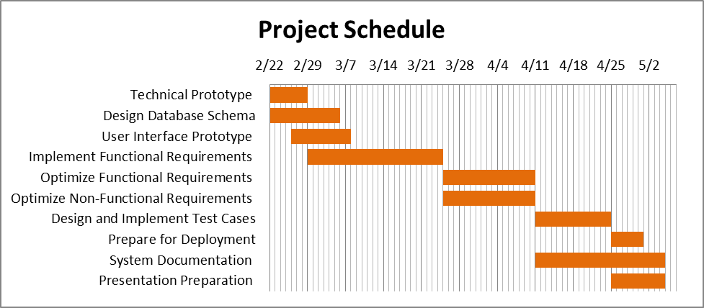

Success Criteria
For this project to be considered a success, all of the following criteria must be met:
- All essential requirements of the product are met.
- The product is ready to be installed at the time of presentation.

Definitions

Evolution of the Project Plan
This section describes plans for updating the project plan throughout the project.

Partial Example
Before the start of an iteration, the project plan will be updated to include a schedule of detailed tasks for the upcoming iteration. At the conclusion of an iteration, the project plan will be updated to include the actual effort for each completed task.
Risk mitigation efforts will be evaluated at the start of each iteration. Severe risks will be analyzed and added to the project plan as soon as they materialize.

Startup Plan

Team Organization
This section explains project roles and the authorities and responsibilities associated with these roles. Lines of communication, authority and reporting relationships are often shown with an org chart. If development team is known, actual names can be associated with roles.
Project Manager: The project manager is responsible for creating the project plan (with input from those doing the work), managing risks, running the weekly team meeting and providing monthly status reports to senior management. The Project Manager reports to the Senior Project Manager (Eddie Burris) and the customer (Commerce Bank).
Programmers: Programmers are primary responsible for coding and unit testing modules. They are also expected to take part in architecture planning and review meetings. Programmers report to the Software Architect.
Database Admin: The Database Admin is responsible for designing the database schema, choosing the DBMS, implementing the schema, and configuring a web hosted database for development use. The Database Admin reports to the Software Architect.
UI Designer: The UI Designer is responsible for designing the GUI layout and developing the UI prototype, which must be approved by the customer before implementation. The UI Designer reports the project manager.
Software Architect: The Software Architect is responsible for the technical design of the product, and ensuring that all components of the product work together as expected. The product design is given to programmers for implementation. The Software Architect reports to the Project Manager.

Project Communications
Item / Event | Information | Audience & Deliverable | Frequency
Status Update | Discussion regarding what has been accomplished since the last update and what is planned to be accomplished before the next one. This is also a good chance to discuss problems encountered and to ask for help. | All team members attend. Verbal confirmation of work done and commitment towards future work. | Every Other Day
Team Meeting | Discuss progress so far, |  | Weekly
Issue Tracking

Technical Process
This section describes the software development methodology or conventions the team agrees to live by. When following an organization standard process, this section will refer to the standard process and state any deviations that are planned for this project. In the absence of an organization standard process, this section will define planned phases, entry and exit criteria for each phase, major milestones, workflows, and other aspects of the proposed development process.

Tools
This section specifies the development tools the team will be using to perform their work.

- Programming Language – Java
- Framework Tools – SpringBoot
- Version Control – source code and written artifacts will be stored in a Git repository available on Github.
- Defect tracking – defects and issues will be tracked using Github.
- Build tools – local and main builds will be done using Gradle.
- Automated testing – unit tests will be implemented with the JUnit testing framework.
- Planning – Iteration planning will be done on Trello.
- Communication – Primary team communication will take place on Slack.

Work Plan

Activities and Tasks
A work breakdown structure is an excellent tool for identifying a complete list of tasks.
Depending on the needs of the project, some or all of the following attributes will be recorded for each task:
- Task name
- Task Description
- Owner
- Effort estimate
- Actual effort
- Planned start and stop dates
- Actual start and stop dates
- Dependencies among other tasks

Release Plan
For day-to-day project management the release and iteration plans (described in the next section) are probably the two most important project management artifacts.
The release plan lists expected completion dates for major milestones and delivery dates of key work products. The project’s technical development process to a certain extent will dictate the choice and timing of milestones and deliverables. For example, projects following the Rational Unified Process will have four major milestones: life-cycle objectives, life-cycle architecture, initial operation capability, and product release.

Iteration Plans
View past, present and future iteration plans on Trello.

Budget
The project budget is the projected cost of the project as a function of time. At any point in the project you should be able to say how much money has already been spent and estimate of the amount of money needed to complete the project.

Control Plan

Monitoring and Control
Include in this section plans and procedures for tracking progress and controlling performance. Included here will be the approximate dates of technical as well as managerial reviews. Typically each major milestone or project phase will end in a review.
For projects that don’t have a separate communication plan, this section may also include information on the timing and content of status reports and other project review documentation.
Daily – Status update. Team members discuss what they are currently working on and any problems they might face.
Weekly – Team meeting. Project participants decide what needs to be worked on next and who should be assigned what tasks.
Biweekly – Sprint Retrospective. Use the start, stop continue method to evaluate the previous iteration and plan the next. Each team member will identify specific things that the team should start doing, stop doing and continue doing.
3/25/2016 – Sprint Review. Display the team’s accomplishments thus far to Commerce and receive vital feedback which will guide the rest of the project.
5/5/2016 – Final Review. The team presents the product to Commerce Bank.

Project Measurements
Product and process measures support project management and estimation by analogy. At the beginning of a project, estimates are made for product size, project cost and delivery dates. During a project, progress is tracked with measures of actual effort, integrated lines of code and actual expenditures. Keeping track of estimates and actuals during a project helps to calibrate whatever technique is being used to make estimates. Storing project performance data on completed projects provides a rich source of data for estimating future projects.

Example
Phase | Measurement | Source
Release Planning | Record effort estimates for product features | Mgr
Iteration Planning | Record effort estimates for scheduled tasks  Update effort estimates for product features  Update estimated dates in release plan | Mgr
Iteration Closeout | Record actual effort for scheduled tasks  Record actual effort for product features  Record LOC count for modules written | Mgr/Pgr
System Test | Record the rate at which errors are found. | QA
Project Closeout | Archive project performance data in process database. (See process database definition for a list of measures to record.) | Mgr
Ongoing | Record defects found from integration testing through first year of release.  Assign each defect to one of the following categories: blocker, critical, major, minor or trivial. Keep track of the state of each defect: open, assigned, fixed, closed. | Mgr/Pgr/QA

Supporting Process Plans

Risk Management Plan
Identify technical and managerial risks. Prioritize risks. Consider the probability of each risk turning into a problem and the likely consequences. For the highest priority risks, what actions will be taken to minimize the probability of the risk turning into a problem and the resulting consequences? What are the contingency plans for selected risks that do become a problem? Identify processes for monitoring risks and updating the risk management plan.

Configuration Management Plan
Configuration management plans for this document and other baselined work products including review procedures and change management procedures.

Partial Example
- All work products will be stored in a centralized CVS repository running on a central server.
- The naming convention for documents will be: NNN-VVV.suffix where NNN is a mnemonic that reflects the function of the document, VVV is a 3 digit version number, and 'suffix' is the standard/normal suffix for the document type. For example, the second version of the requirements document created as a Microsoft Word document might be labeled: REQ-002.doc.
- All project (work products) items (documents, source code, test cases, program data, test data, etc) will be stored in the CVS repository but not all will be under change control (subject to formal change control procedures.) Only the system requirements, project plan and source code will be baselined and under configuration control.
- Items that are subject to change control will be considered baselined after a group review at the end of the life cycle phase during which they are created. Baselined here means that the product has undergone a formal review and can only be changed through the prescribed change control procedures.
- The change control procedure once a product is baselined is: (1) anyone wanting to make a change to a baselined item sends an email to the rest of the group describing the change, reason for the change, expected impact, and timeline for integrating the change. (2) if no one responds to the group within 2 days with a reason for why the change request shouldn't be permitted, it will be considered accepted and the person proposing the change may proceed with the change. If anyone does object to the change, the reason for objecting will be discussed at a meeting where everyone is invited to attend and voice their opinion. At the end of the meeting a democratic vote will be held to decide whether or not the change should be allowed.
- Including a change history with all documents is encouraged but only required for baselined documents. The change history should be at the front of the work item and include: (1) the name of the person making the change, (2) brief description of what has changed, (3) reason for the change, and (4) the date the change was integrated.

Verification and Validation Plan
The verification and validation plan defines what actions are being taken to assure the quality of the development process and resulting software products.

Partial Example
The Verification and Validation plan is specified as a separate documented located in the version control system at: http://company.com/svn/project-name/docs/VandVPlan.doc

Product Acceptance Plan
The product acceptance plan defines what is acceptable in terms of product quality and product functionality. Acceptance criteria should be objective and measurable. Note product success is one aspect of project success. Teams wanting to establish a clear understanding of what will be considered acceptable project performance may want to define a more general plan for project success that includes quantitative goals for delivery date, cost, etc.

Partial Example
The Verification and Valida

